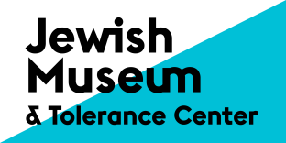
The Jewish Museum and Tolerance Center presents the exhibition of Gerhard Richter: Abstraction and Appearance
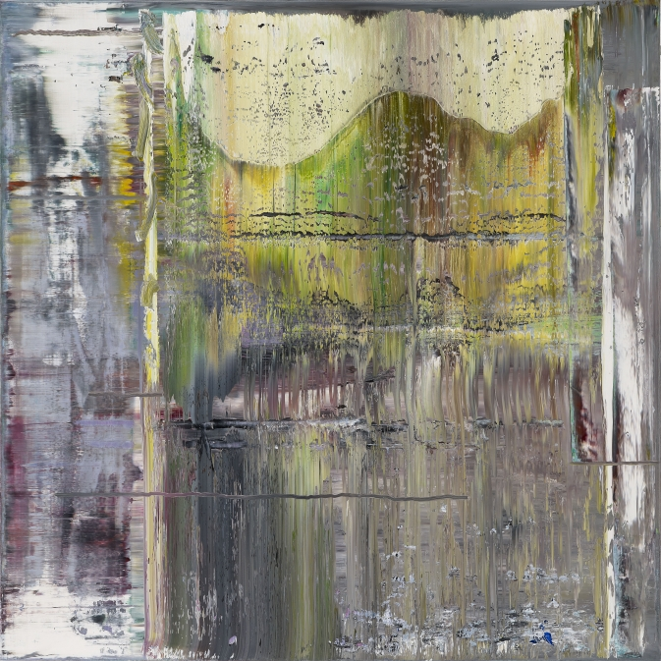
November 9, 2016 – February 5, 2017
Gerhard Richter is one of the most foremost modern artists in the world; the central theme of his oeuvre for more than 50 years has been the exploration of appearance in our perception of reality.
This groundbreaking exhibition at the Jewish Museum and Tolerance Center is devoted to Richter’s involvement with abstraction and includes key works in various media from 1973 to 2016. It surveys important stages in the artist’s development and major works shown include Gray (1973), Aladin(1999), Haggadah (2006), Strip (2013/2016) and a selection of recent Abstract Paintings (2016). The center of the exhibition comprises a special installation devoted to Birkenau (2014), a series of four recent large-format abstract paintings which were created in response to photographs taken by a prisoner at the Auschwitz-Birkenau Concentration Camp in August 1944. Suggesting that any attempt to express this tragedy by realistic painting is forlorn, the Birkenau paintings make the original images unrecognizable, and use abstract painting to convey a powerful emotional message. The installation includes four full-sized original photographs and 93 photographic details of the same works, exploring Richter’s parallel involvement with the role of replication in our experience of appearance. These works are among the most significant in modern art in recent years.
Richter’s investigation of perceived appearances is developed in other parts of the exhibition: and other works displayed include: Halifax (1978); 128 details of an abstract painting; War Cut (2004), mounted layout of the book of abstract details combined with newspaper excerpts about the beginning of the first Gulf war; the special project Museum Visits, comprising a selection of 24 overpainted photographs; together with the series Elbe, November and Tag, as well as Spiegel Grau (1991), one of Gerhard Richter’s most famous mirror works.
Gerhard Richter created his first works in1962 using found photographs. At first, the artist used images taken from magazines and family albums and also photographs given to him by friends. Working with that material he transformed photographs into painted portraits, landscapes, still-lives and cityscapes. The artist’s early figurative paintings provide a multi-faceted portrait of the world and established his reputation. Those works, many of which appear blurred, commenced Richter’s involvement with the relation of appearance and reality, a complex relationship that he described in the following way:
“I don’t mistrust reality, of which I know next to nothing. I mistrust the picture of reality conveyed to us by our senses, which are imperfect and circumscribed.” (G. Richter)
That singular involvement with the nature of appearance subsequently developed in the form of abstract paintings, a way of working that commenced in the early 1970s, and which, from then onwards, forms the main trajectory of his development. This important aspect of Richter’s work provides the focus of the exhibition, the central theme of which is encapsulated in the artist’s comment that :
“You want to understand what you see and you try to make a picture out of it. Later you realize that you can’t represent reality. All what you see represents nothing but itself, and therefore is itself reality.” (G. Richter)
The exhibition has been curated by Paul Moorhouse, art historian and Senior Curator, 20th century at the National Portrait Gallery, London.

Andrey Sakov / PR
Andrey.s@jewish-museum.ru
+79856327820

